**SP17 – HCI BIOMETRIC ACCESS Sneha Palvai**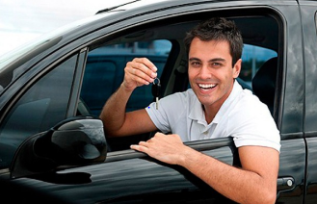

Persona:

Name: Mr. Charles Kate

Age: 29 years old

Designation: Sr. Architect Engineer

Annual income: $300k

Background:

Mr. Kate is a successful Sr. Architect Engineer, wherein he has to attend several business trip meetings. He has a small family with 2 kids and lovable wife. As a token of appreciation, every year he receives incentives by which he can plan trips with his family too or go for shopping.

His main goal is to develop the commercial levels of his company by adding some interesting features by making changes in his day to day life. Now, he is looking forward to buy a new car with some advanced new features and get rid of his old car for enjoying the pleasure in a luxury car.

In his busy schedule, Kate has to drop his kids at Kindergarten and he really has no time to have his breakfast sometimes and he was awake too late and has to rush to his office. He usually forgets his keys and goes down till parking. He will be really frustrated. Sometimes it might be late and he tries to adjust their seatbelt for kids as they face difficulty in fixing their seatbelt and to open doors manually. If he has a car with finger touch access that automatically opens door and locks/unlocks seatbelt.

My infotainment system Biometric Access will help him to get access to his car in the case he forgets his keys at home. Once the kids into their seats, he doesn’t have to adjust their seatbelts manually, wherein he can start keyless engine and at the same time he can fix everyone’s seatbelt automatically with just a fingerprint access. Kids also can fix their belts just by giving their access if they face difficulty in adjusting their belts. Meanwhile, if they are hungry Kate have to purchase any chocolates for them which is again a great delay for him to reach his office. Instead of purchasing and stopping in between, they can directly have some food or juices preserved in mini refrigerator just by his/ kids access.

Scenario:

Kate has two 5 year old kids. In his busy schedule, Kate has to drop his kids at Kindergarten and has to rush to his office. He detects car parking spot from his mobile which was synchronized from his car. If he has a car with finger touch access, he can automatically open door, START his keyless engine and locks/unlocks seatbelt of his own and kids and can grab some juice or water from his mini storage refrigerator opening with his biometric metric. He added his family members for access. He dropped kids and then finally reach his office making his life move in a comfortable manner.

Story Board Sketching

